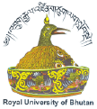
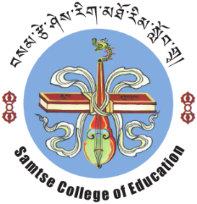
Royal University of Bhutan
Samtse College of Education
“You cannot give what you do not have.”Druk Gyalpo
Acceptance of an Offer for the PGDE programme
Offer Date: January, 2020
Programme Title:  Postgraduate Diploma in Education (PGDE) | Applicant’s Name:
Programme Title:  Postgraduate Diploma in Education (PGDE) | School Name:
Programme Title:  Postgraduate Diploma in Education (PGDE) | Dzongkhag:
Programme Title:  Postgraduate Diploma in Education (PGDE) | Date of birth:
Programme Title:  Postgraduate Diploma in Education (PGDE) | Emp. ID/CID No:
Course commencement date:  February, 2020  Course completion date:  June, 2021 | Email:
 | Phone number:
 | Mobile number:
 | Emergency Contact name:
 | Relationship:
 | Phone number:
 | Mobile number:
 | Email:

- I am pleased to accept a place in the above course
- I declare that the information provided above is correct and complete
- I agree/accept to pay the total course fee of Nu. 104565.00 (one hundred four thousand five hundred and sixty-five only) at the time of registration in:
  - full payment □
  - two instalments □
  - three instalments □
Applicant Signature………………………………………..Date:……………………………

Note: Please return to Programme Leader via email attachment
Email : kdorji.sce@rub.edu.bt, Contact Number: +975 17618945
: 05 365391(President) 365274 (Adm) 365273 (Office) 365363 (Fax) P.O Box No. 329
Visit us at www.sce.edu.bt

