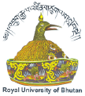
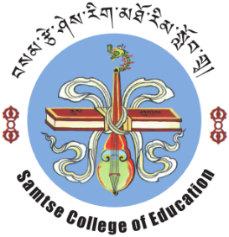
Royal University of Bhutan
Samtse College of Education
“You cannot give what you do not have.”Druk Gyalpo
Acceptance of an Offer for the PgDCCP programme
Offer Date: 05 July, 2021
Programme Title:  Postgraduate Diploma in Contemplative Counselling Psychology (PgDCCP) | Candidate’s Full Name:
 | Village: | Gewog:
 | Dzongkhag:
 | Date of birth:
 | CID No:
Course commencement date:  August, 2021  Course completion date:  December 2022 | Email:
 | Phone number:
 | Mobile number:
 | Emergency Contact name:
 | Relationship:
 | Phone number:
 | Mobile number:
 | Email:

- I am pleased to accept a place in the above course
- I declare that the information provided above is correct and complete
- I agree/accept to pay the total course fee of Nu.102516.00 (one lakh two thousand five hundred and sixteen only) in:
  - full payment □ b. two instalments □ c. three instalments □
Applicant Signature………………………………………..Date:……………………………

Note: Please return to Programme Leader via email attachment
Email: ddoma.sce@rub.edu.bt; copy to srinchen.sce@rub.edu.bt (Dean, AA)
Contact Number: +975 17397040
: 05 365391(Director General) 365274 (Adm) 365273 (Office) 365363 (Fax) P.O Box No. 329
Visit us at www.sce.edu.bt

